**ITC515-Professional Programming Practice – Assignment 4**

**Suyog Rajbhandari-11619832**

**BUG 5 – SPADE dice value never appears**

**Description:** Even player rolls thousand times, he never get the SPADE value.

1. **Replication.**

Even after fixing the bug 4, which allows player to get 3 dice values randomly but the SPADE does not show up in every roll:

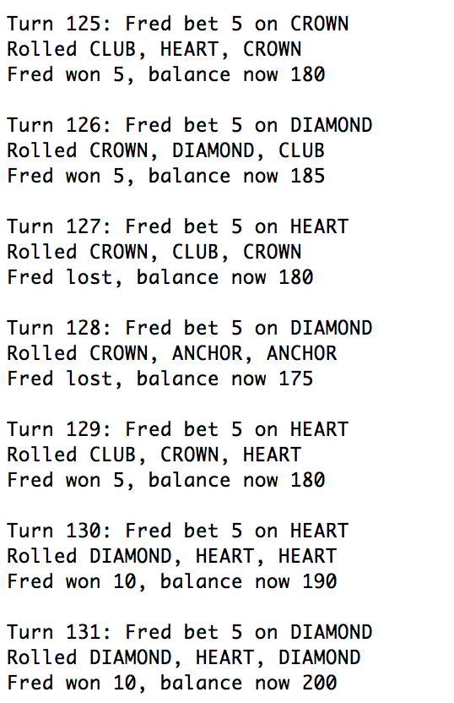

**2. Simplification.**

Start at the Main class, we can see that the Dice Value generated inside the playRound() method. In there, the Dice is rolled and the value gets generated when the Dice is rolled. Which means the Dice Value is randomly generated in the below method: (which is implemented in the DiceValue class):

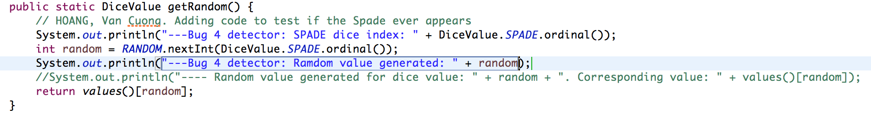

Debuging messages are added to see if the random number evers reach to the SPADE index in the ENUM array. And the console shows:

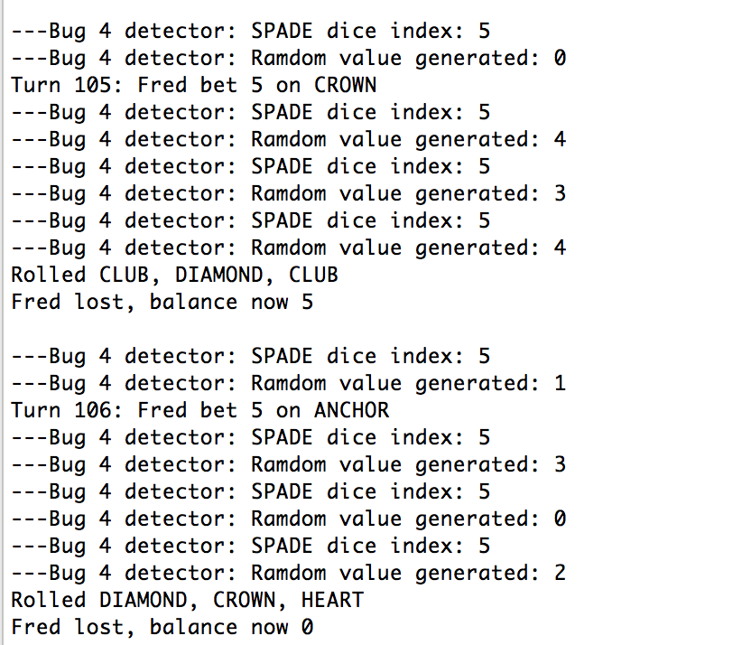

While the index of SPADE is 5, the random number only reaches to the maximum of 4.

As a result, we can assure that the random number causes the bug.

**3. Tracing.**

The bugging point once identified, there are several approaches to solve it. Please read the comments in the screenshots below to see the tracing:

Which says that the random number should be from 0 to 5.

**4. Resolution**

Extending the range of random number generated will solve the issue:

Now we run the game again to check if the bug fixed:

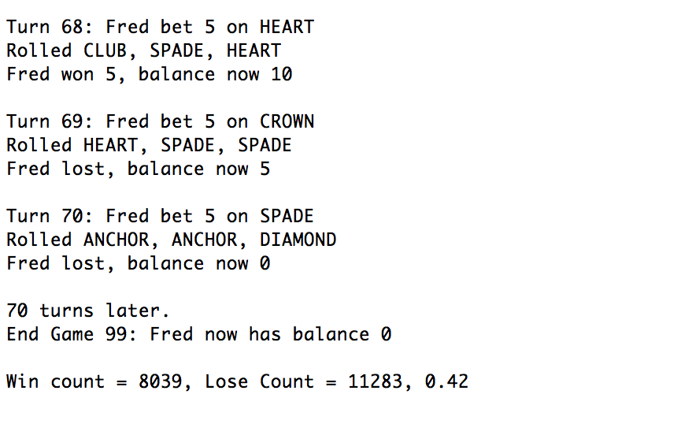

Clearly, the SPADE now appears. And at this stage, the bug number 3 (inappropriate ratio of winning/losing) is also fixed.